**République Algérienne Democratique et Populaire Ministére de l’Ensignement Supérieur et de la Recherche Scientifique**

**Univeraité des sciences et de la technologie Houari Boumediene**



***Finale Project***

***report on information and communication technologies (TIC) and related technologies.***

*\*Exploring Innovation and Connectivity\**

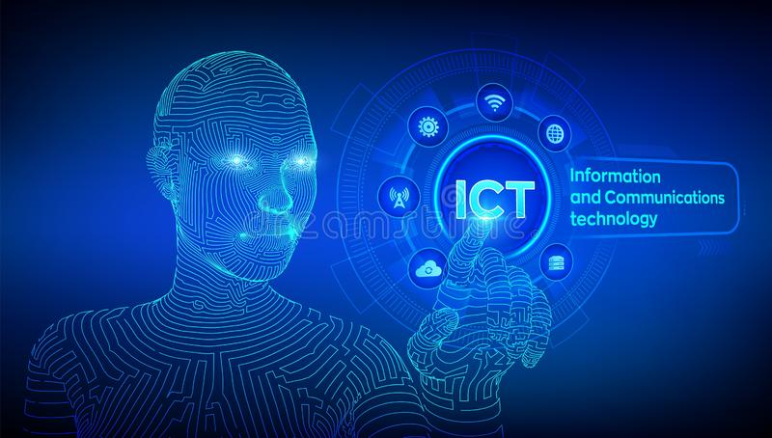

**Prepared by Groupe 17**

**Introduction:**

**information and communication technologies (TIC) aim to be the core of innovation in the digital age, playing a pivotal role in shaping how we perceive and interact with the world technological advancements and innovation in this field are accelerating, and the impact of TIC is actively evident in various aspects of our lives. In this report: this report delves into the opportunities and challenges associated with TIC, with a specific focus on Google Services, Microsoft Tools, The Git System, and the GitHub platform, among other related technologies. we embark on an exploratory journey through the different dimensions of this field from foundational technologies to practical applications in diverse domains.**

**Report objectives: our objective is to gain a profound understanding of the role of TIC and its impact on improving communication, facilitating business operations, and driving the wheel of innovation. We will carefully examine specific technologies, providing a comprehensive view of how they integrate into our daily lives and societies.**

**Through the pages of this report, we will explore a wide range of concepts and applications that embody the technological spirit of the modern era.**

Definition of TIC :

**Information and Communication Technologies (ICT) encompass a set of specialized technologies involved in collecting, processing, and transmitting information. These technologies provide clear examples of the transformation brought about by technological advancements.**

**1-Internet: Enables individuals and institutions to communicate and access data globally.**

**2-Business Software: Such as Customer Relationship Management (CRM) systems, contributing to improved interaction with customers.**

**3-Data Analysis Techniques: Empower the use of big data and artificial intelligence techniques for strategic decision-making.**

**4-Smartphones and Applications: Enhance communication and facilitate access to information through various applications.**

**5-Social Networks: Like Facebook and Twitter, forming a platform for exchanging information and social interaction.**

**6-Information Security: Providing technologies and solutions to protect data from security threats.**

**7-Cloud Computing: Offering computing resources online, contributing to cost reduction and increased efficiency.**

**These examples demonstrate the interactive nature of ICT components and their impact on the evolution of communication and information management in the modern era.**

**THERE are many technologies related to TIC such as :**

GOOGLE SERVICE

 ****Google service is a very important search engine for all parts of the world that can help you in your daily life, google mission is to organize information on a global scale with the goal of making it accessible and useful to everyon**e**

**-Major sections of google service**

****Google Search:** is a service provided by the company for users to search for information on the internet. Google's search engine is considered one of the most popular and widely used engines globally. It allows users to enter search queries to find web pages and information related to their topics. It relies on complex algorithms to determine the relevance of pages and rank them based on significance**

****Email and Communication Service:** A suite of tools and platforms, including Gmail, Google Meet, and Google Chat, designed to streamline electronic communication, foster collaboration, and enhance connectivity among users.**

****Documents and productivity services:** refer to a set of tools and platforms designed to create, edit, and collaborate on digital documents, enhancing overall efficiency and productivity.**

****Maps and Location Services:** A set of tools and platforms dedicated to mapping and navigation, providing users with geographical information, directions, and location-based services.**

****Analytics and marketing services:** involve the analysis of data to gain insights into user behaviour and trends, aiding businesses in making informed decisions for effective marketing strategies**

****Cloud and Development Services**: Providing online computing resources and tools for application development, deployment, and management.**

****Al and machine learning services:** Leveraging artificial intelligence and machine learning technologies to enhance various applications and processes.**

**Security services: Providing security services to ensure the protection of data and information from security threats.**

-Example about google service

Google's services encompass the search engine, facilitating quick access to information, and advanced features like Google Photos for secure storage of photos and videos. Additionally, YouTube serves as a leading platform for watching and sharing videos.

**1-Gmail: is a popular email service developed by Google, offering users a secure and user-friendly platform for communication. Known for its efficient spam filtering, generous storage capacity, and seamless integration with other Google applications, Gmail has become a widely used and trusted email solution.**

**2- YouTube: a captivating digital canvas, invites users to weave a tapestry of visual stories. As a dynamic video-sharing realm under Google's umbrella, it unfolds a kaleidoscope of creativity, offering a global stage where diverse content blooms — from enchanting entertainment to enlightening education, transcending borders and captivating audiences with the artistry of moving images.**

3-Maps: **Google Maps is a digital cartographer's masterpiece, seamlessly blending art and utility. It unfolds a virtual atlas, empowering users to navigate the intricate tapestry of the world. From turn-by-turn directions and real-time traffic updates to immersive Street View experiences, it's a versatile companion for exploration. With its ability to unearth local gems and streamline travel, Google Maps reshapes our understanding of space, transforming the mundane act of navigation into a visually rich and interactive journey.**

**-Microsoft Tools and integration with TIC**

|  |  |  |
| --- | --- | --- |
| Tools | Description |  |
| **Microsot365** | is an integrated suite of productivity tools and cloud services, including popular applications like Word and Excel, collaborative platforms like Teams, and cloud storage through OneDrive. It offers a comprehensive solution for modern work, promoting efficiency and collaboration. |  |
| **Teams** | is a collaborative platform facilitating communication through chat, video meetings, and file sharing. It integrates with Microsoft 365 apps, providing a centralized space for teams to collaborate in real-time. |  |
| **Share point** | is a collaborative platform fostering efficient document management and teamwork. It provides structured spaces for secure information sharing, version control, and streamlined workflows, contributing to enhanced organizational productivity. |  |
| **Azure** | Azure is Microsoft's cloud platform offering a range of services including computing, storage, databases, AI, networking, and more. It enables businesses to build, deploy, and manage applications globally, providing scalability, flexibility, and a robust set of tools for various IT needs. |  |
| Power bl | Power BI is a Microsoft analytics service for visualizing and analyzing data. It connects to diverse data sources, supports AI integration, and enables users to create interactive reports and dashboards for informed decision-making and collaboration. |  |

**-GIT AND GitHub**

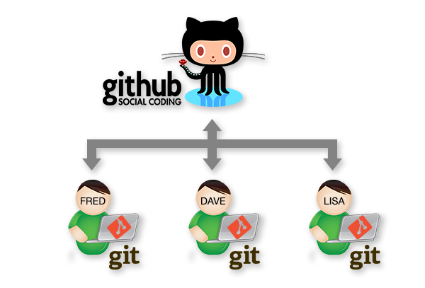

**GIT: a masterpiece in version control, orchestrates the symphony of collaborative software development. Crafted by Linus Torvalds, it elegantly tracks code changes, allowing a ballet of developers to harmonize their efforts. With its decentralized architecture, Git empowers teams to seamlessly branch, merge, and sculpt the evolution of their codebase. Its speed and flexibility transform version control into a fluid dance, enhancing the rhythm of innovation in both small projects and grand endeavours.**

****GIT HUB:** is the digital agora where the artistry of coding finds its canvas. Born from the foundations of Git, it is more than a repository; it's a collaborative sanctuary for developers. Here, lines of code become threads in a tapestry of innovation. With its pull requests, issue tracking, and project management tools, GitHub orchestrates a ballet of collaboration, where contributors from around the globe converge to create, refine, and inspire. It's not just a platform; it's a testament to the collective brilliance of the coding community.**

****-The difference between GIT and GIT hub :****

**Git is a distributed version control system, focusing on local code management and allowing individual developers to track changes, create branches, and maintain a comprehensive history of their code. On the other hand, GitHub is a web-based platform built around Git, providing a centralized space for collaborative development. GitHub enhances Git by offering features like pull requests, issue tracking, and project management tools, facilitating team collaboration and serving as a hub for sharing and hosting Git repositories online. While Git is the version control system itself, GitHub acts as a collaborative platform that utilizes Git for efficient and centralized code sharing and collaboration.**

****-Conclusion:****

**In culmination, the symphony of Information and Communication Technologies (ICT) and their companions in innovation orchestrates a crescendo of transformative possibilities. As we navigate this digital overture, the harmonious integration of cloud computing, advanced analytics, and collaborative platforms emerges as the virtuoso ensemble driving organizational evolution. Just as a skilled conductor Molds disparate instruments into a harmonious melody, strategic ICT integration orchestrates operational efficiency, agility, and a responsive cadence to the demands of the contemporary technological landscape. In this ever-evolving score, organizations that embrace ICT not only communicate; they compose a symphony of innovation, propelling themselves into the crescendo of success in the digital era.**